REHUBA ITC AIRLINES

­­­­­­­­­­­­­[AIRLINES MANAGEMENT SYSTEM]

BUSINESS SPECIFICATIONS REQUIREMENT

**TABLE OF CONTENTS:**

# **OBJECTIVE**

# **INTRODUCTION**

# **PROJECT SCOPE**

# 

# **USER COMPONENTS :**

# **2.1 : REGISTERATION PAGE**

# **2.2 : LOGIN PAGE**

# **2.3 : MAIN PAGE**

# **2.4 : BOOKING PAGE**

# **2.5 : ABOUT US PAGE**

# **2.6 : CONTACT PAGE**

# 

OBJECTIVE :

Airline reservation systems were first introduced in the late 1950s as relatively simple standalone systems to control flight inventory, maintain flight schedules, seat assignments and aircraft loading. The modern airline reservation system is comprehensive suite of products to provide a system that assists with a variety of airline management tasks and service customer needs from the time of initial reservation through completion of the flight. One of the most common modes of travel is traveling by air. The objective of the Rehuba airline Web application is The customer who wish to travel by Rehuba airlines should be able to book an airline Ticket from the comfort of their home or from anywhere Through the Rehuba airline Ticket booking web application.

The user of the Rehuba airline ticket booking web application should be able to create his own account by registering in the registration page. After registering, the user of the Rehuba airline ticket booking web application should able to login and navigate to all other pages that provides information about contact details, information about the airline and also to the booking page where the user/customer of the Rehuba airline should able to book airline tickets only to the countries where Rehuba airlines offers Air Transport services By providing Travelling details such as Departure & arrival destination, Departure & Arrival date, first and last Name of the customer/user ,Preffered Seating, And contact details.

# Introduction

## Purpose

This SRS document presents a detailed description of the Airline Flight Booking system, version 1.0. It represents the client requirements analysis that defines the functional and non- functional requirements of the airline website and its different functionalities. It defines the abilities, reactions from stimuli, guidelines and limitations of the system. This document will be complete in its scope of the system and the functions required. The system provides a solution to allow the user to search for flights satisfying the user criteria, to reserve seats, to manage the user account, and to book a flight.

## Project Scope

The airline booking website is an application stored in the user server. The purpose of the website is to resolve the client to allow website users to perform tasks related to booking an airline flight. Non-member users are only allowed to search for available flights; non- member users are required to create an account in order to reserve a seat or to book a flight. Member users have the right to search for available flights, to reserve a seat, to book a flight, cancel a flight and to edit their member information. Member users are required to login into their account prior to flight booking.

**USER COMPONENTS**

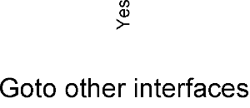

**2.1) REGISTRATION PAGE :**

This page in Rehuba Airline management Should let the user to Register his details with Rehuba airline ticket booking web application and proceed with further steps.

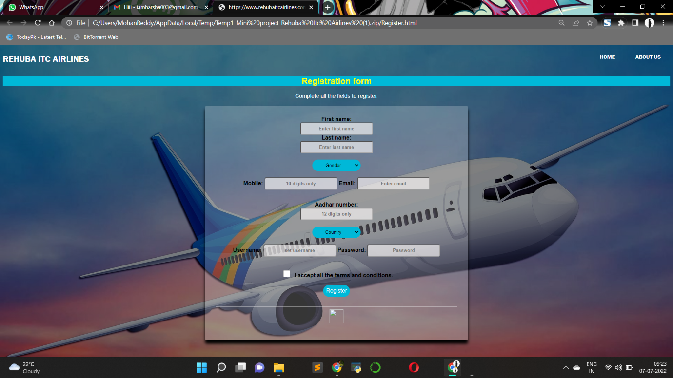

**Required Fields :**

* Personal Details of User
* Contact Details of User
* Govt. ID for Verification
* Valid Username for Login
* Valid Password for Login
* Terms and Conditions

**REQUIREMENTS:**

* First name textfield should follow first character uppercase and remaining lowercase letters.
* Last name textfield should follow first character uppercase and remaining lowercase letters.
* Mobile textfield maximum length is 10 digits.
* Adhar number textfield maximum length is 12 digits.
* Username textfield should consists of combination of uppercase and lowercase letters.
* The maximum length of username is 8-16 characters.
* Password textfield should consists of combination of uppercase and lowercase and numerical.
* The maximum length of password is 8-16 characters.

**2.2) LOGIN PAGE :**

This page should let only the registered users into the main page of the Rehuba airline ticket booking web application.

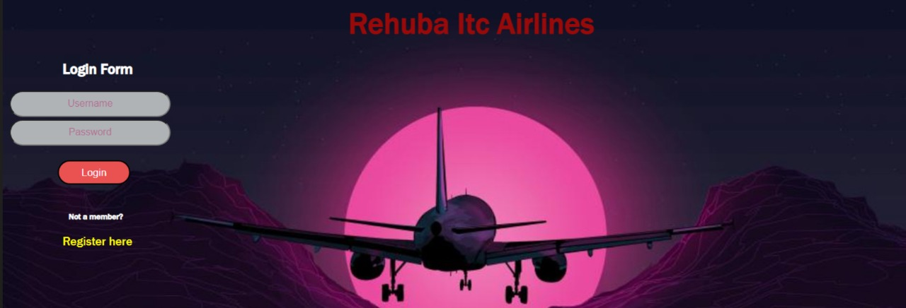

**Required fields :**

* Login fields
* Register as New User
* Link for Registering

**2.3) MAIN PAGE :**

This page Should display the details and other options to perform other actions such as Contact us and,About us.

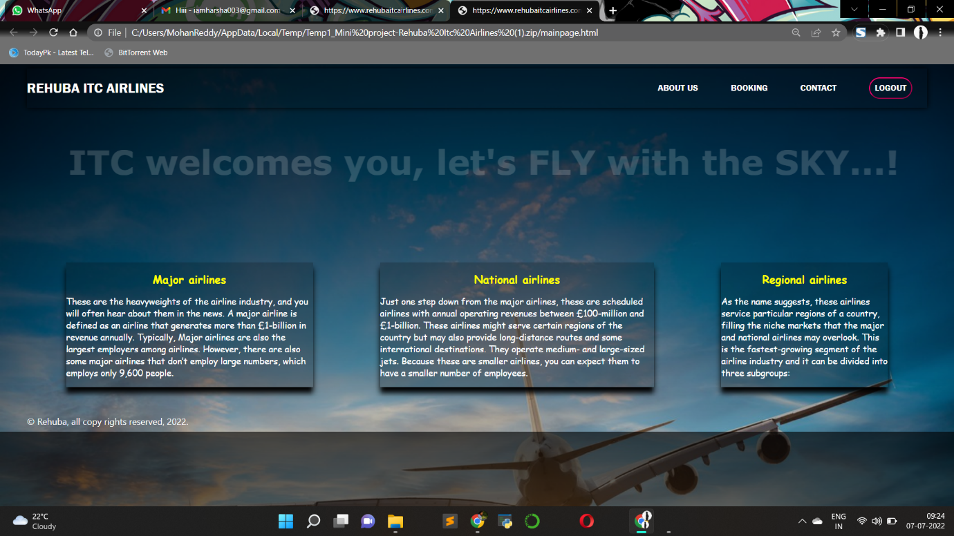

**Required fields :**

* A Brief information about our services
* Contact for help
* Navigation to Booking page

**2.4) Contact us page :**

This page Should display the contact details to the users ,who navigate from main page to this page.

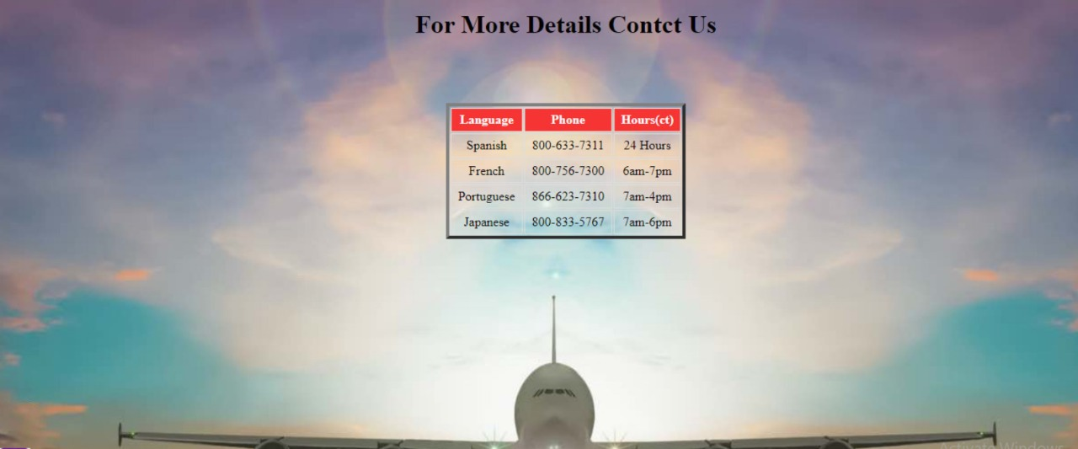

**Required fields :**

* Description about services
* Help section
* Query section
* Leave Feedback

**2.5) About us page :**

This page Should display to the users the details of “Rehuba airlines” to the users who navigate from main page to this page.\

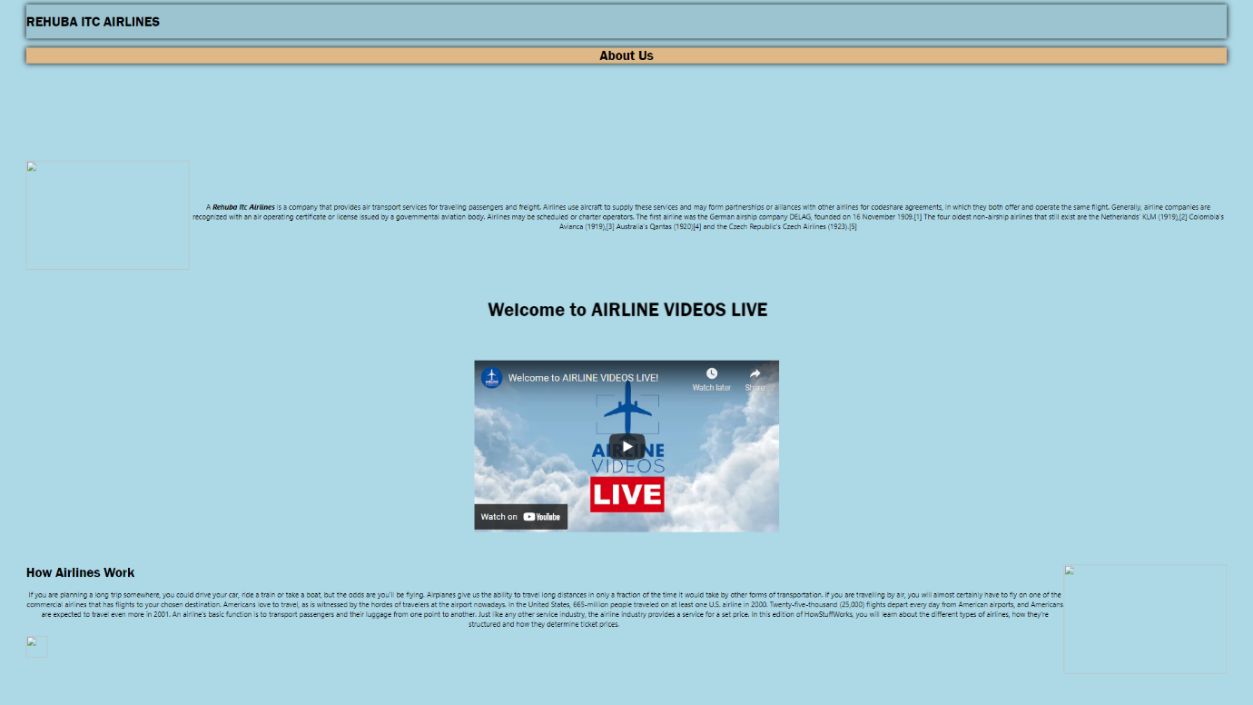

**Required fields :**

* Description about services
* Help section
* Query section
* Leave Feedback

**2.6) Booking page :**

This page Should let the users to book tickets to the preferred destination among the destinations where air transport services are offered by “Rehuba Airlines” by entering the details that is asked in the booking webpage.

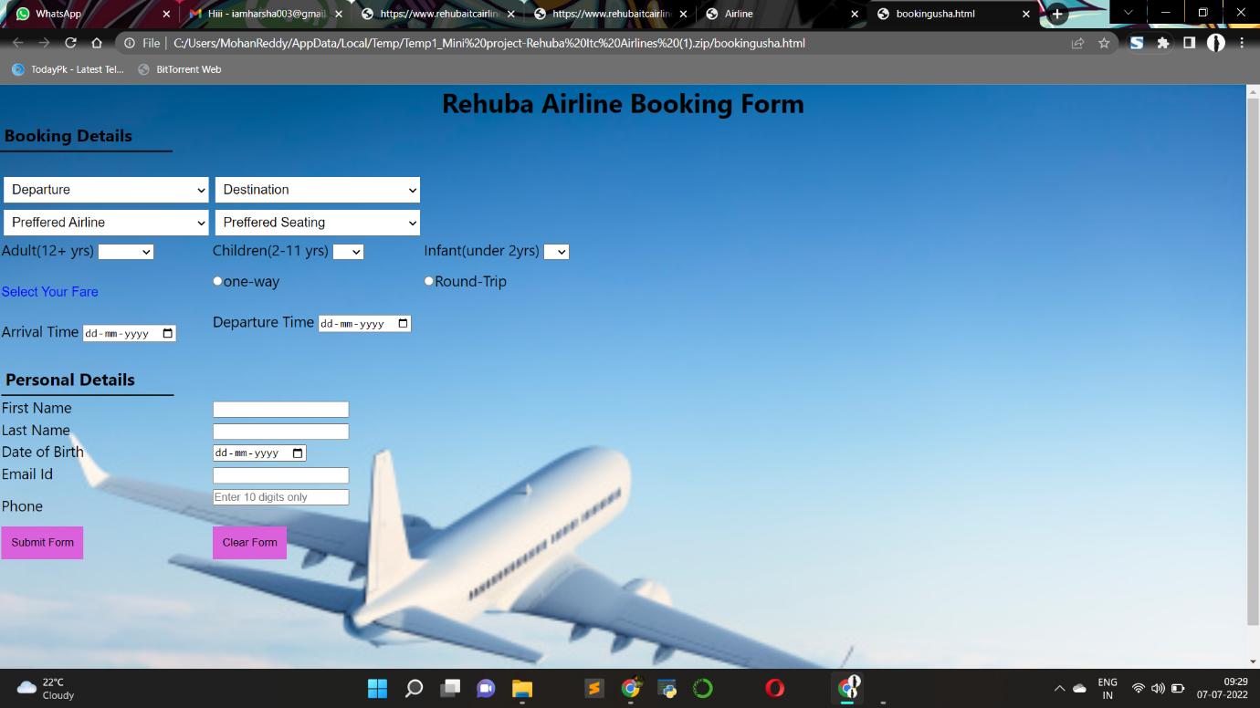

**Required fields :**

* Booking Details like Departure & Destination
* Preferred Airlines
* Preferred Seating
* Add Infants
* Fare Selection
* Personal Details
* Final Submit

